WARNING: If you are using a Firefox Browser to submit an eOffer you may encounter an error message when responding to the SubKPlan Questionnaire “101185 sub-k plan is incomplete”. Please import your digital certificate to an Internet Explorer Browser and follow the instructions provided below.

On the Standard Response Initial Page, scroll down to the Subcontracting Plan decision. Then select the appropriate radio button to respond.
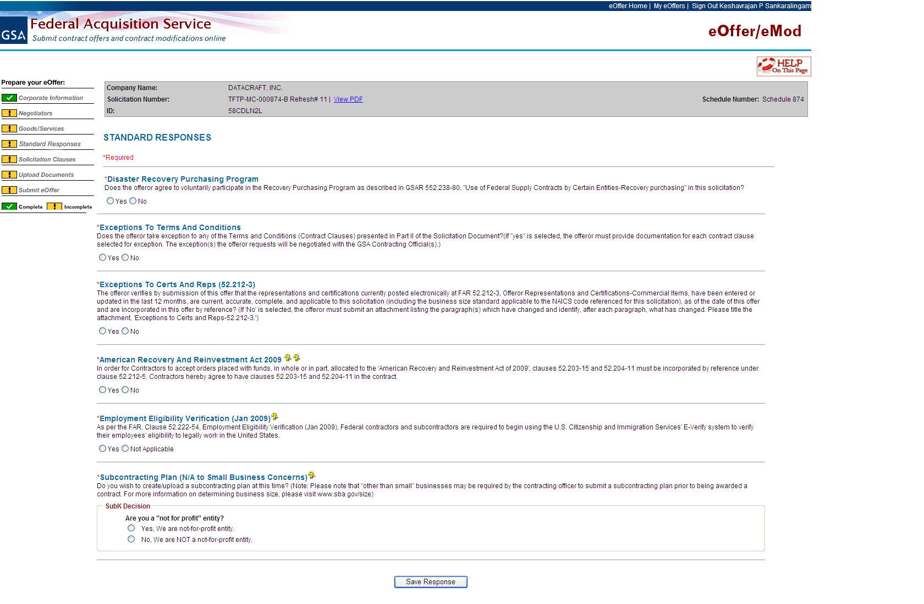

After selecting the radio button for the SubK Plan Questionnaire, the next question will appear. Continue to select the appropriate response until you have completed all the questions.
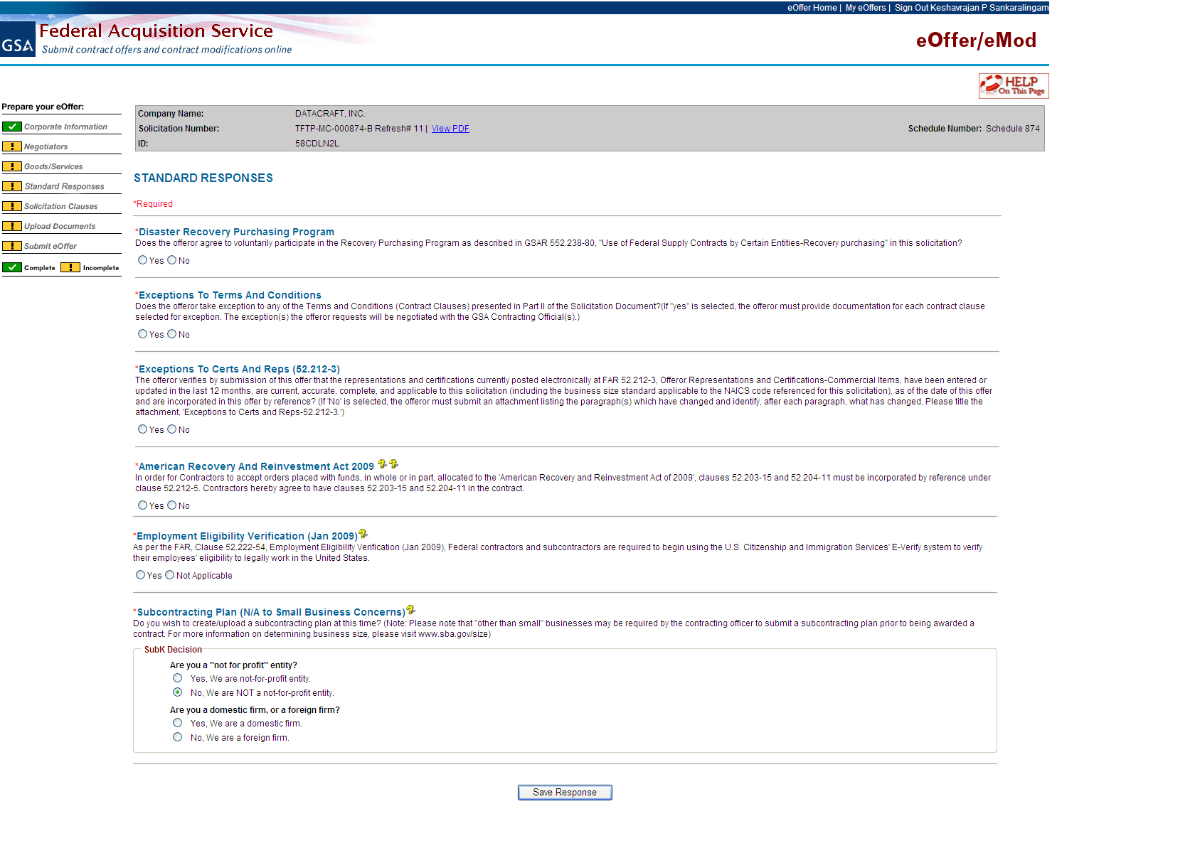

If you clicking on “Save Response” without responding to the next radio button you will get an error because you have not completed.
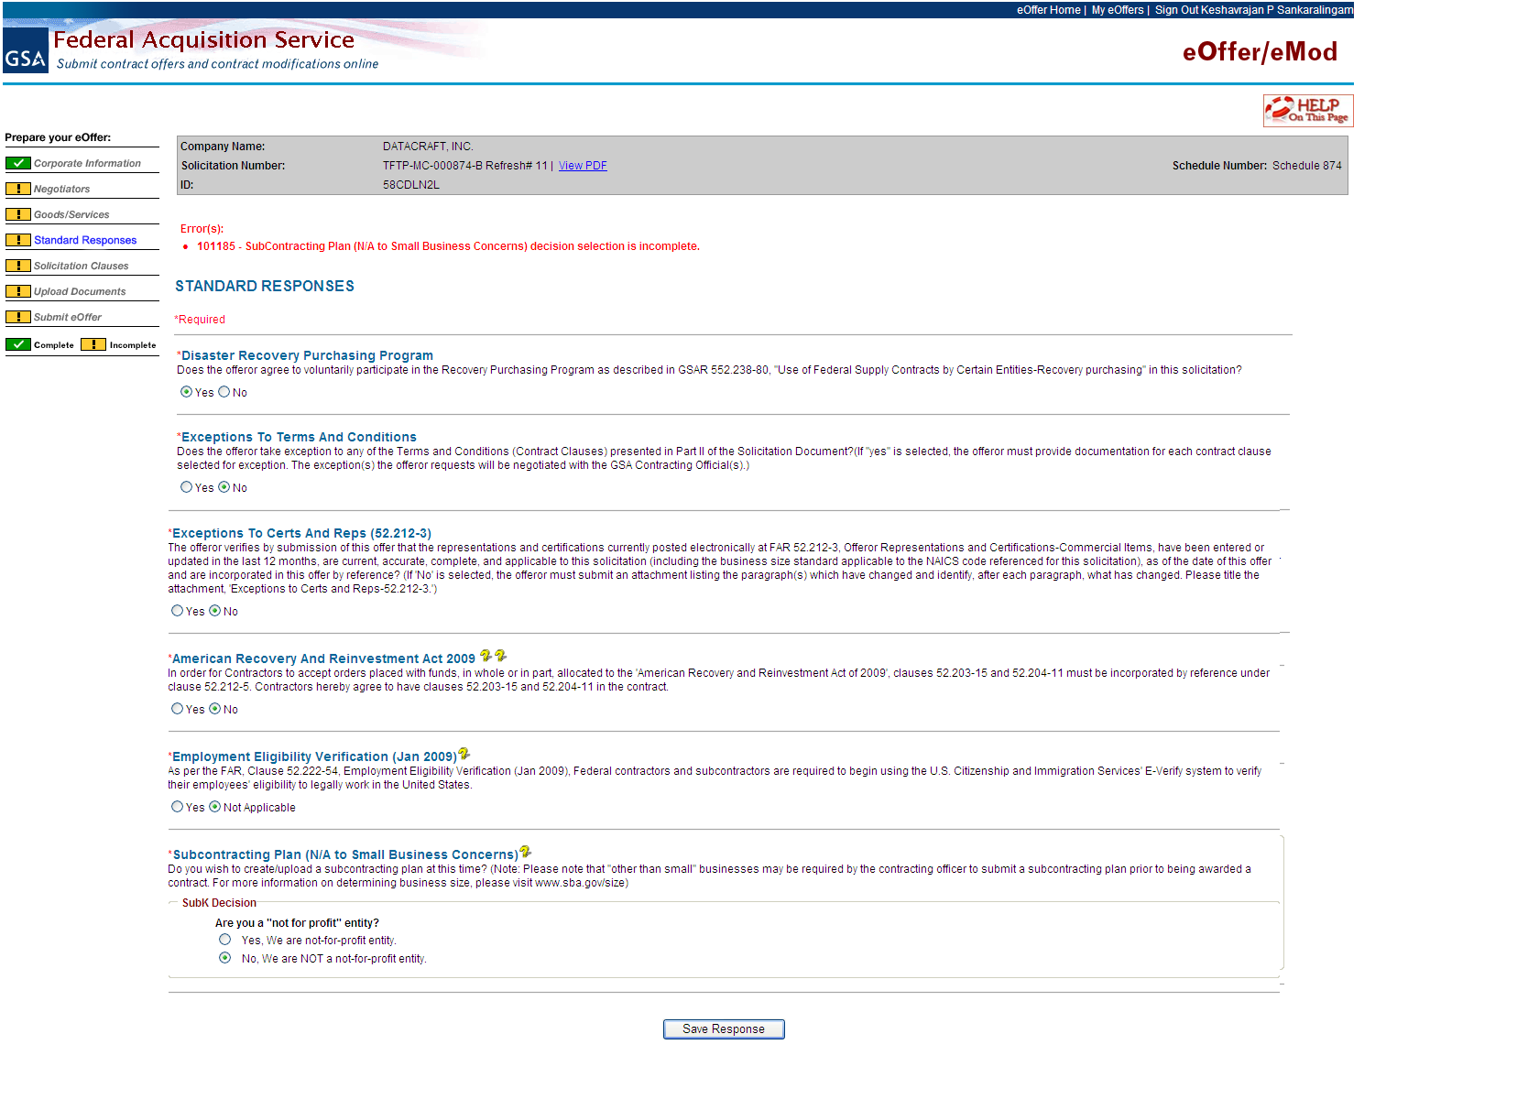

Make a selection to continue the eOffer process:
To continue eOffer process, without getting stuck, please click on the radio button again. The next set of questions will pop up again.

